

Figure 1. Schematic representation of the flavonoids biosynthetic pathway. PAL: phenylalanine ammonia lyase; 4CL: 4-coumarate:coenzyme A ligase; C4H: cinnamate 4-hydroxylase; CHS: chalcone synthase; CHI: chalcone isomerase; F3H: flavanone-3-hydroxylase; F3’H: flavonoid-3’-hydroxylase; F3’5’H: flavonoid-3’5’-hydroxylase; FLS: flavonol synthase; DFR: dihydroflavonol reductase; 3-GT: flavonoid 3-O glucosyltransferase; 5-GT: flavonoid 3-O glucosyltransferase; AAC: anthocyanin acyltransferase; RT: flavonoid 3-O-glucoside-rhamnosyltransferase.

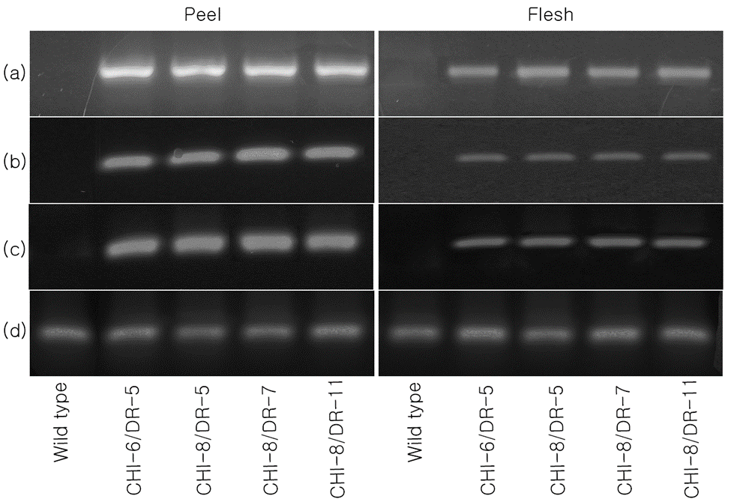

Figure 2. Schematic expression of Reverse trascriptase PCR (RT-PCR) for each CHI/DR line, in peel and flesh: (a) CHI primer (b) Del primer (c) Ros primer (d) Housekeeping gene primer, PePP2ACS, which is used for equal loading.

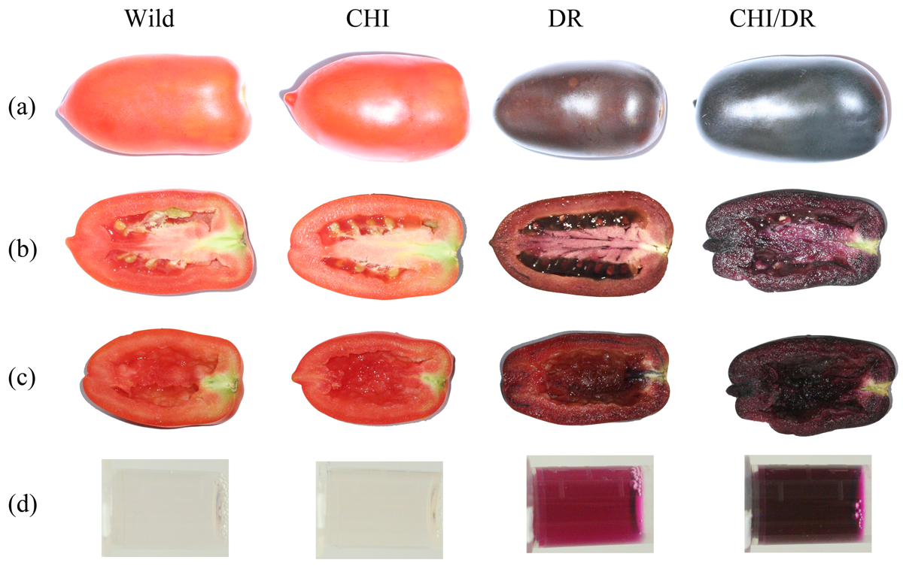

Figure 3. Color expression in T2 and F2-generation tomatoes (cv. Rubion), expressing , *CHI* and *CHI/DR or both*: (a) whole fruit (b) dissected fruit with seeds (c) dissected fruit without seeds (d) extracted anthocyanin

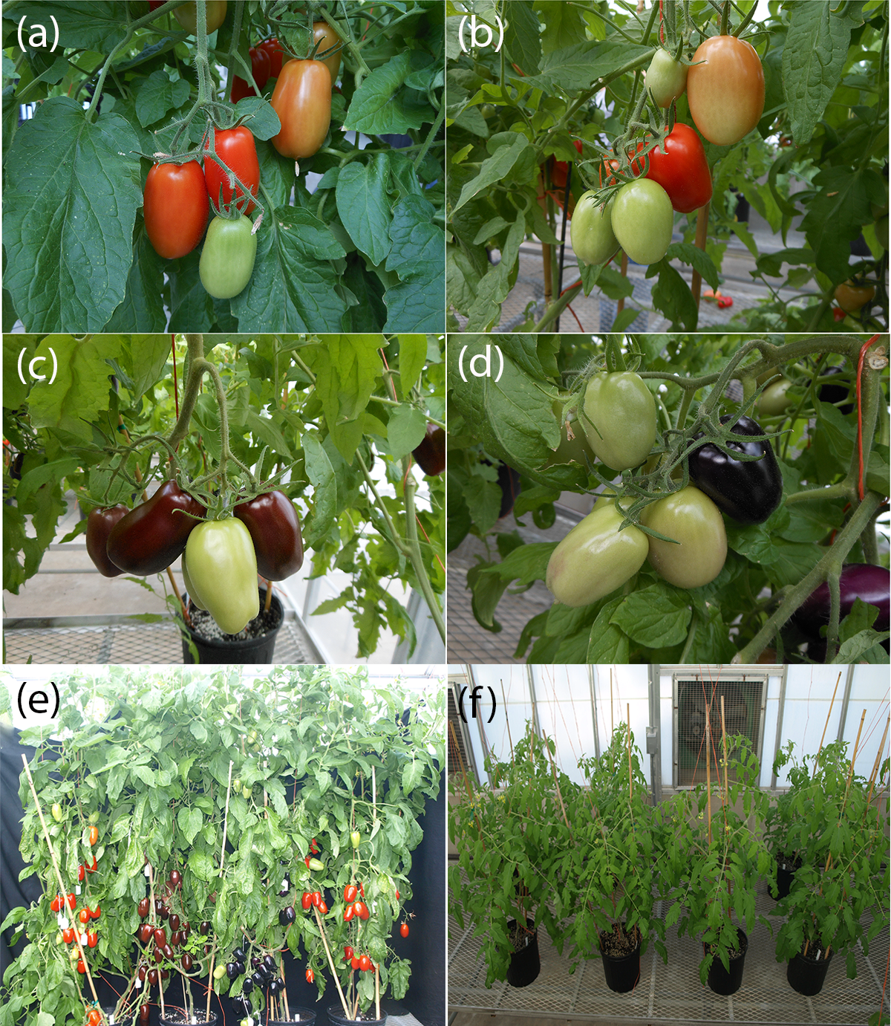

Figure 4. Fruits in plant and whole plant (a) Wild (b) CHI (c) DR (d) CHI x DR (e) and (f) wild, DR, CHI x DR and CHI from left, (a) – (d) show various ripening states



Figure 5. Total Anthocyanin content in (a) peel and (b) flesh and total flavonol content in (c) peel and (d) flesh (CHI lines have T2 generations.). Values with the same letter are not significantly different at 0.05 using the Tukey test. Tomatoes were harvested 20 d after breaker stage. The data represent the mean values (±SD) derived from 5-7 plants per each line (4 to 6 pooled tomatoes per plant).



Figure 6. Flavonols from skin: (a) quercetin-3-B-D glucoside (b) rutin (ckaempferol-3-rutinoside (d) quercetin (e) naringenin (f) naringenin chalcone (F2 CHI/DR population). Values with the same letter are not significantly different at 0.05 using the Tukey test. Tomatoes were harvested 20 d after breaker stage. The data represent the mean values (±SD) derived from 5-7 plants per each line (4 to 6 pooled tomatoes per plant).



Figure 7. Flavonol from flesh: (a) Quercetin-3-B-D glucoside (b) Rutin (c) Kaempferol-3-Rutinoside. Values with the same letter are not significantly different at 0.05 using the Tukey test. Tomatoes were harvested 20 d after breaker stage. The data represent the mean values (±SD) derived from 5-7 plants per each line (4 to 6 pooled tomatoes per plant).



Figure 8. Lycopene content in (a) peel and (b) flesh and antioxidant activity in (c) peel and (d) flesh. Tomatoes were harvested 20 d after breaker stage. The data represent the mean values (±SD) derived from 5-7 plants per each line (4 to 6 pooled tomatoes per plant).